Lab 4: Frequency

Section 02

Jonathan Pilling

***Abstract-* We were able to build a filter that passed sinusoids of frequencies of about 0 Hz (DC) and 3 kHz, and blocked frequencies of about 1 kHz and infinity (high frequency). The 1 kHz and 3 kHz frequencies are within the band of audio sounds we could perceive, and the effect of the filter may be heard using earbuds. The input to the filter for this lab was a triangular waveform, which was equal to a summation of sinusoids of frequency 1 kHz, 3 kHz, 5 kHz, etc. The filter altered the shape of the triangular waveform by blocking the 1 kHz component.**

1. **Introduction**

In many engineering applications, it’s important to be able to select signals of a given frequency, or some signals out of a band of frequencies. For example, to be able to pick out the signal from thousands of transmitted radio signals. A tuner selects a specific frequency and rejects all other frequencies. Another example is an equalizer in an audio system. This equalizer is able to reject and allow certain frequencies to change the way the music can be emphasized. In this lab we designed a frequency-selective circuit based on circuit shown in Fig. 1. The circuit will strongly reject a 1 kHz frequency and strongly pass a 3 kHz. This circuit is a combination of a band-pass and a band-reject filter.

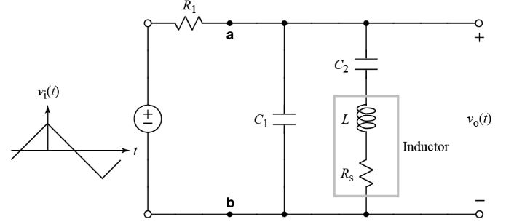

Figure . Circuit for combined band-pass and band-reject filter

Following this report, we will talk about the filter circuit design. We will also characterize the filter frequency response. We will then finally look at the effect of our filter on a triangle wave.

1. **Filter Circuit Design**

The transfer function of the filter is given by the ratio of the phasor for the output, to the phasor for the input. To achieve the behavior of a band-reject filter, the impedance of L and C2 is designed to be zero at 1 kHz. At resonance, the impedances are equal but one is positive imaginary and the other is negative imaginary. To achieve behavior of a filter that passes a 3 kHz signal, the combination of C1 and L plus C2 must look like an open circuit at that particular frequency. We needed to derive an equation for C2 so that in terms of L and ω, the circuit rejected frequency ω1. Deriving an equation for C2 we get equation 1.

|  |  |  |
| --- | --- | --- |
|  |  | (1) |

Computing this value, we got C2 = 253 nF.

Next we needed to derive an equation for the value of C1 that must satisfy in terms of L, C2, and ω1 so that the circuit will allow a frequency of 3ω1 to pass through. Again, using a value of L = 100 mH, we were able to derive and calculate equation 2.

|  |  |  |
| --- | --- | --- |
|  |  | (2) |

Evaluating this expression we get C1 = 32 nF.

1. **Characterization of Filter Frequency Response**

Measuring the circuit components was very straight forward with an ohmmeter. Using the ohmmeter, you just have to connect the red and black jumper-like cables to the ends of the different circuit components. When measuring components, you have to make sure to adjust the knob in the center to reflect close to the actual value of the circuit components, or else you will just get a value of one on screen. In fig. 2 you will see the expected and measured values for all circuit components.

|  |  |  |
| --- | --- | --- |
| **Components** | **Expected** | **Measured** |
| R1 | 10 kΩ | 9.95 kΩ |
| L | 100 mH | 97.7 mH |
| Rs | 0 Ω | 62.6 Ω |
| C1 | 32 nF | 31.3 nF |
| C2 | 253 nF | 254 nF |

Figure . Table of expected vs. measured values

Frequency response was measured by setting the input waveform to a sinusoid. Using a 1 V amplitude input, we measured the amplitude of the filter output for frequencies between f = 0 Hz to 6 kHz. We used MATLAB to plot the ideal, predicted and measured frequency response.

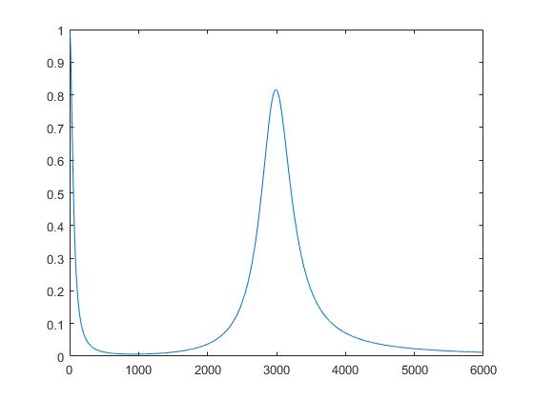

Figure . MATLAB plot with ideal values

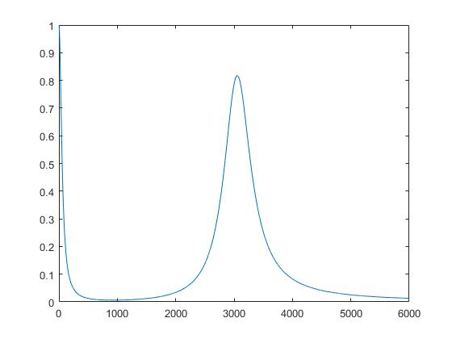

Figure . MATLAB plot with measured values

**Conclusion**

In many engineering applications, frequency selection can be of critical importance. This could be a life saving device when it comes to radio communication between emergency dispatch officials. This could also be a device used for fun i.e. an equalizer. Equalizers are a frequency selection-type device. In this lab we designed a frequency-selective circuit based on circuit shown in Fig. 1. The circuit strongly rejected a 1 kHz frequency and strongly allowed a 3 kHz wave to pass. We were able to model with MATLAB how this frequency response circuit would behave before we built it.

**Appendix**

function H = Hjw(omega) %HJW Script File

% usage: Vo = VRLC(omega)

% Computes the voltage across series impedance of R, L, and C when

% driven by current i(t) = 3cos(omega*t) A.

% R = 100 ohms

% L = 10 mH

% C = 1 uF

% Define component values.

R1 = 9.95e3;

Rs = 62.6;

L = 97.7e-3;

C1 = 31.3e-9;

C2 = 254e-9;

%Compute z values.

zC1 = -1j./(omega .* C1);

zC2 = -1j./(omega .* C2);

zL = (1j .* omega .* L + Rs);

%Might need to add in Rs....

zSubtotal = zC2 + zL;

zTotal = (zC1 .* zSubtotal)./(zSubtotal + zC1);

% By Ohm's law, Vo = I*zTot. So H = Vo/I = zTot.

H = zTotal/(R1 + zTotal);

return

end

%% Script to plot the function

Warray = linspace(1, 6000, 5999);

Harray =[];

%Creates the Harray

for i = 1:5999

Harray = [Harray, Hjw(i * 2 * pi)];

end

plot(Warray, Harray)